

**School of Biological Sciences**

**ASSESSMENT COVER SHEET**

**Section A**

|  |  |  |  |  |  |  |
| --- | --- | --- | --- | --- | --- | --- |
| **Student Number** | **2502495** | | | | | |
| **Programme** | Bioinformatics (MSc) | | | | | |
| **Unit Name** | Scientific Programming | | **Unit Code** | BIOLM0032_2023_TB-1 | | |
| **Assessment Name** | Scientific Programming Project | | | | | |
| **Word Count** | **Under 2000 words for the report.** | | | | | |
| **Do you give permission for you work to be used anonymously in examples given to students in the future?** Yes | | | | | | |
| **Title of the Project** | | Scientific Programming Assessment | | | | |
| **Title of the Scientific Report** | | **Simulation of the System – Simplified Model of the Propagation of a Forest Fire.** | | | | |
| **Course Leader** | | **Matt Williams** | **Attendance** | | **In-person and Online** | |
| **Date of Submission** | | 12:59 PM Friday, 19 January 2024 | | | | |
| **Location** | | Life Science Building (LSB), School of Biological Sciences, Faculty of Life Sciences, University of Bristol | | | | |
| **Marks Based on the Final Programming Project** | | **100%** | **No. of Credits** | | | **20** |

Malmfors (2000)

**By submitting this assignment cover sheet, I confirm that I understand and agree with the following statements:**

* 'I have not committed plagiarism, cheated or otherwise committed academic misconduct as defined in the University's Assessment Regulations (available at <https://www.bristol.ac.uk/media-library/sites/academic-quality/documents/taught-code/annexes/university-examination-regulations.pdf>)
* 'I have not submitted this piece, in part or in its entirety, for assessment in another unit assignment (including at other institutions) as outlined in section 4 of the University's Assessment regulations (available at <https://www.bristol.ac.uk/media-library/sites/academic-quality/documents/taught-code/annexes/university-examination-regulations.pdf>)
* I understand that this piece will be scrutinized by anti-plagiarism software and that I may incur penalties if I am found to have committed plagiarism, as outlined in sections 3 of the University’s Examination Regulations (available at <https://www.bristol.ac.uk/media-library/sites/academic-quality/documents/taught-code/annexes/university-examination-regulations.pdf>)

**Table of Contents**

**Simulation of the System – Simplified Model of the Propagation of a Forest Fire** 1

**1.0 Overview/Literature Review** 1

**2.0 Introduction to the Forest Fire Model** 1

**2.0 Project Planning** 1

**3.0 Simulation Rules** 4

**4.0 Dynamics of the Enhanced Model** 4

**5.0 Visualisation and Analysis** 4

**6.0 Applications and Insights** 5

**7.0 Limitations and Real-world Relevance** 6

**8.0 Conclusion** 6

**References** 7

**No table of figures entries found.**

**O'Connor, M. (1992)**

# **Simulation of the System – Simplified Model of the Propagation of a Forest Fire**

**Drossel, B.; Schwabl, F. (1992)**

**Accessible via my GitHub Repository** [**https://github.com/2502495/Forest_Fire_Model**](https://github.com/2502495/Forest_Fire_Model)

The format of this Scientific Report is taken from the Skills Team, University of Hull available on University of Bristol BlackBoard® Day, R.A. (1998), and Teaching and Learning Support (TaLS) – Fact Sheets from University of Bristol Blackboard®.

# **1.0 Overview/Background-Literature Review van Emden, J.,**

See files attached. The forest fire model, a prominent paradigm in non-equilibrium statistical mechanics, represents a network of interacting elements displaying the fascinating phenomenon of SOC. This behavior manifests as seemingly random critical events emerging spontaneously throughout the system, despite the absence of centralized control or explicit external forcing.

# **2.0 Introduction to the Forest Fire Model Montgomery, S.L. (2003)**

The Forest Fire Model is a cellular automaton, a grid-based computational model that simulates various systems through simple rules. We consider a discrete lattice with Ld sites, where L denotes the grid side length and d represents its dimensionality. Each site can exist in three distinct states: vacant, occupied by a tree, or burning. The model's dynamics are governed by a set of transition rules applied synchronously across all sites at each time step. The key parameter, p/f, dictates the average number of trees grown between two lightning strikes, essentially controlling the system's propensity for criticality. Each cell in the grid represents a part of the forest and can exist in one of three states: empty, occupied by a tree, or on fire. The model evolves over discrete time steps, with the state of each cell at a given time determined by its previous state and the states of its neighboring cells.

# **2.0 Project Planning**

Complete Anaconda-Navigator™ **User Manual** attached. Documentation hosted by Read the

Docs©. Click the following link to access Read the Docs Anaconda-Navigator Manual

((Anaconda, 2018). Created using [Sphinx](https://www.sphinx-doc.org/) 5.0.2. Built with the [PyData Sphinx Theme](https://pydata-sphinx-theme.readthedocs.io/en/stable/index.html) 0.14.4.

Also, find attached complete Anaconda-Navigator™ **Tutorial**. Documentation hosted by Read

the Docs©. Click the following link to access Read the Docs Anaconda-Navigator Tutorial

((Anaconda, 2018). Created using [Sphinx](https://www.sphinx-doc.org/) 5.0.2. Built with the [PyData Sphinx Theme](https://pydata-sphinx-theme.readthedocs.io/en/stable/index.html) 0.14.4.

**Within the realm of dynamic systems theory, a crucial distinction lies between continuous and discrete systems.** Whereas continuous systems utilize **differential equations**, relating a function's rate of change to its current state, **discrete systems** employ **difference equations**, capturing state transitions at discrete time intervals. **Difference equations** represent the core mathematical framework for **discrete dynamical systems**. These equations relate the state at a future time step to the state at the current time step, effectively dictating the system's evolution by discrete jumps. Examples abound, from population growth modeled by the logistic map to financial market dynamics captured by difference equations with stochastic elements. While continuous systems often find grounding in classical mechanics principles, **discrete systems offer distinct advantages**. Their step-wise nature facilitates efficient numerical simulations and readily lends itself to modeling inherently discrete phenomena like cell division or financial settlements. Additionally, **hybrid systems** employing **differential-difference equations** can bridge the gap between continuous and discrete worlds, capturing complex dynamics with mixed timescales.

**In essence, the power of discrete dynamical systems lies in their ability to model complex systems exhibiting discrete state transitions with elegance and computational efficiency.** Their applications span diverse fields from biology and economics to computer science and engineering, making them a cornerstone for understanding and predicting the behavior of a vast array of real-world systems.

This section proposes a 2D multi-state cellular automaton (PCA) for forest fire modeling, building on the 2-state version. Here's the key idea:

**Fire intensity matters:** Instead of just "burning" and "not burning," cells now have multiple states representing different fire intensities (0-n). 0 is unburned, n is completely burnt, and 1-n-1 are various burning stages.

**Probabilities vary with intensity:** The chance of fire spreading from a cell depends on its intensity (p(i)). Higher intensity means higher chance.

**Burning cells evolve independently:** After igniting, a cell's intensity fluctuates randomly (aij) without influencing neighbors.

**Neighbors influence ignition only:** Unburned cells can catch fire based on the intensities of their neighbors (ni(x, t) * p(i)).

**Key equations:**

* p(i): Probability of fire spreading from intensity i
* ni(x, t): Number of neighbors with intensity i at time t
* aij: Probability of intensity i changing to j (excluding 0 and i)
* P{s(x, t + dt) = j | s(x, t) = i}: Conditional probability of cell i changing to j after dt

**Benefits:** This multi-state model captures the nuances of fire intensity, leading to more realistic simulations compared to the simplistic 2-state version.

**2.01 Model Initialization**

The simulation begins by initialising a grid where each cell is randomly assigned a state based on predetermined probabilities. This randomness introduces variability, ensuring diverse outcomes akin to the natural distribution of trees and the initiation of fires in forests. Several parameters drive the model:

**2.02 Parameters**

**Lightning Probability:** Determines the chance of a tree catching fire independently, simulating the effect of lightning strikes.

**Tree Growth Probability**: Governs the likelihood of an empty cell turning into a tree, representing natural tree growth.

**Wind Effect Probability:** A novel addition to the model, this factor influences the spread of fire, simulating how wind can exacerbate wildfire propagation.

# **3.0 Simulation Rules**

The evolution of the Forest Fire Model follows a set of rules, applied at each time step:

**Burning Trees:** A tree on fire becomes an empty cell in the next time step, representing the tree burning down.

**Fire Spread:** If a tree is adjacent to a burning tree, it catches fire, depicting the direct spread of fire from one tree to another.

**Lightning Strikes:** Trees have a probability of spontaneously catching fire, mimicking the random nature of lightning strikes.

**Tree Growth:** Empty cells can grow new trees based on a certain probability, reflecting natural forest regeneration.

**Wind Effect:** This new rule accounts for the acceleration of fire spread due to wind, adding complexity to the fire dynamics.

# **4.0 Dynamics of the Enhanced Model**

The interplay of tree growth, lightning strikes, and wind effects leads to rich and complex behaviors in the simulation. A higher tree growth rate and low fire probability can result in a dense forest, while high fire probability can lead to frequent and widespread fires. Introducing the wind effect adds another layer of complexity, potentially leading to more aggressive and less predictable fire spread patterns.

# **5.0 Visualisation and Analysis**

The model includes an animation component, visually representing the forest state over time (Figure 1). This animation is crucial for understanding the dynamic nature of wildfire spread. Additionally, the model computes the proportions of trees and fires over time, (Figure 2) plotting these trends to investigate the forest's steady-state behaviour under various conditions.

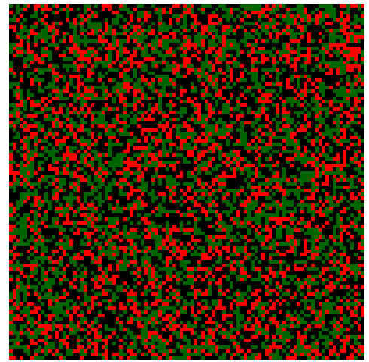

**Figure 1 Forest Fire Model Animation**

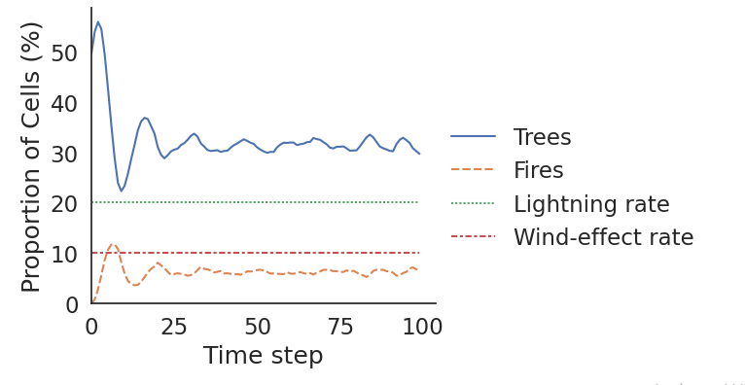

**Figure 2 Trend Investigate the Forest's Steady-State**

**6.0 Applications and Insights**

This enhanced Forest Fire Model is a powerful tool for understanding wildfire behaviour. It can be used to study the impact of factors like forest density, the frequency of lightning strikes, and the role of wind in wildfire propagation. The model also offers a platform for testing firefighting strategies or land management policies in a controlled, simulated environment.

# **7.0 Limitations and Real-world Relevance**

While the model offers valuable insights, it is important to acknowledge its limitations. The homogeneous landscape assumption and the simplistic representation of tree and fire states do not account for the diverse vegetation types, varying topography, or different weather conditions crucial in real-world wildfires. Moreover, the model simplifies the complex chemistry and physics of fire behaviour. Despite these limitations, the model is a significant step towards understanding the complex dynamics of forest fires. It serves as an educational tool, allowing individuals to grasp basic principles of fire spread and the impact of various environmental factors.

# **8.0 Conclusion**

# The enhanced Forest Fire Model is a testament to the power of computational models in simulating complex natural phenomena. It captures the unpredictable nature of wildfires and provides a framework for studying their behaviour under varied conditions. By tweaking the model's parameters, one can observe a range of behaviours, from stable forests with occasional fires to chaotic scenarios dominated by wildfires. Therefore, this model serves as a simulation tool and a gateway to a deeper understanding of the intricate balance in natural ecosystems and the influence of random and environmental factors. The simplified forest fire model serves as a valuable tool for studying criticality in spatially extended systems and provides insights into the dynamics of complex real-world phenomena, including wildfires, disease outbreaks, and social unrest. By analyzing the critical behavior and fire size distribution, we gain valuable knowledge about the interplay between local interactions and large-scale emergent properties, informing risk assessment and mitigation strategies in diverse contexts.

**Envisioning More Future Developments**

A Forest Fire Susceptibility Modeling Approach Based on Integration Machine Learning Algorithm. Shi (2023)

**Updating more future developments and suggestions on my GitHub**

[**https://github.com/2502495/Forest_Fire_Model**](https://github.com/2502495/Forest_Fire_Model)

# **References/Citations**

(Anaconda, I. 2., 2018. *docs.anaconda.com.* [Online] Available at: https://docs.anaconda.com/free/navigator/?utm_source=anaconda_navigator&utm_medium=nav-docs

Drossel, B.; Schwabl, F. (1992-09-14). "Self-organized critical forest-fire model". Physical Review Letters. American Physical Society (APS). 69 (11): 1629–1632.

Malmfors, B., Garnsworthy, P., and Grossman, M. (2000), Writing and Presenting Scientific Papers, Nottingham: Nottingham University Press

Montgomery, S.L. (2003), The Chicago Guide to Communicating Science, London: University of Chicago Press.

O'Connor, M. (1992), Writing Successfully in Science, London: Chapman & Hall.

Shi, C.; Zhang, F. A Forest Fire Susceptibility Modeling Approach Based on Integration Machine Learning Algorithm. Forests 2023, 14, 1506. https://doi.org/ 10.3390/f14071506

Teaching and Learning Support (TaLS) – Fact Sheets <http://www.une.edu.au/current-students/resources/academic-skills/fact-sheet> from University of Bristol Blackboard

van Emden, J., and Easteal, J. (1996), Technical Writing and Speaking: An Introduction, Berkshire: McGraw-Hill Publishing Company.

Wilensky, U. (1999). NetLogo. [http://ccl.northwestern.edu/netlogo/.](http://ccl.northwestern.edu/netlogo/) Center for Connected Learning and Computer-Based Modeling, Northwestern University, Evanston,